**PROJECT REPORT**

The project is based on the use of Integrated Chips(IC). In this project, an electric piano is made using IC 555 chip.

**Integrated Circuits:**  An integrated circuit (IC), sometimes called a *chip* or [microchip](http://searchcio-midmarket.techtarget.com/definition/microchip), is a [semiconductor](http://searchcio-midmarket.techtarget.com/definition/semiconductor) wafer on which thousands or millions of tiny resistors, capacitors, and [transistor](http://searchcio-midmarket.techtarget.com/definition/transistor)s are fabricated. An IC can function as an [amplifier](http://searchcio-midmarket.techtarget.com/definition/amplifier), [oscillator](http://searchcio-midmarket.techtarget.com/definition/oscillator), timer, counter, computer [memory](http://searchmobilecomputing.techtarget.com/definition/memory), or microprocessor. A particular IC is categorized as either linear ([analog](http://searchcio-midmarket.techtarget.com/definition/analog)) or [digital](http://searchcio-midmarket.techtarget.com/definition/digital), depending on its intended application.

**IC 555:** The **555 timer IC** is an [integrated circuit](https://en.wikipedia.org/wiki/Integrated_circuit) (chip) used in a variety of [timer](https://en.wikipedia.org/wiki/Timer), pulse generation, and [oscillator](https://en.wikipedia.org/wiki/Electronic_oscillator) applications. The 555 can be used to provide time delays, as an [oscillator](https://en.wikipedia.org/wiki/Oscillator), and as a [flip-flop element](https://en.wikipedia.org/wiki/Flip-flop_element). Derivatives provide two or four timing circuits in one package. The 555 timer comes as 8 pin DIP (Dual In-line Package) device. There is also a 556 dual version of 555 timer which consists of two complete 555 timers in 14 DIP and a 558 quadruple timer which is consisting of four 555 timer in one IC and is available as a 16 pin DIP in the market.

An IC 555 timer with the use of each pin is demonstrated below:

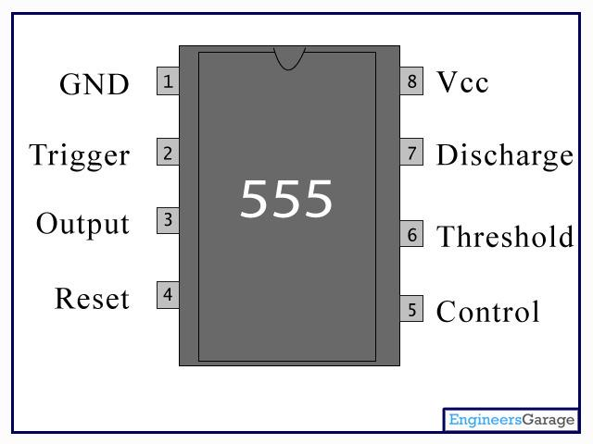

In this project, the 555 timer IC is used in Astable mode to produce a very stable **555 Oscillator** circuit for generating highly accurate free running waveforms whose output frequency can be adjusted by means of an externally connected RC tank circuit consisting of just two resistors and a capacitor.

In order to get the 555 Oscillator to operate as an Astable Multivibrator it is necessary to continuously re-trigger the 555 IC after each and every timing cycle. This re-triggering is basically achieved by connecting the *trigger* input (pin 2) and the *threshold* input (pin 6) together, thereby allowing the device to act as an Astable oscillator. Then the 555 Oscillator has no stable states as it continuously switches from one state to the other.

**8R Speaker:**

**Description:** A small audio speaker that is ideal for radio and amplifier projects and is small enough to fit in robot projects.

**Features:**

* Small Size
* Power rating: 0.5W
* Impedance: 8 ohm

**Dimensions:** 50mm diameter, 16mm high, 28mm base diameter

